Nursery Spring Term 2 Key Texts 2023-2024
O is for Our world and other places
 | Week 1  WB 19.02.24 | Week 2  WB 26.02.24 | Week 3  WB 4.03.24 | Week 4  WB 11.03.24 | Week 5  WB 18.03.24 | Week 6  WB 25.03.24
Little Foxes  Key Texts | 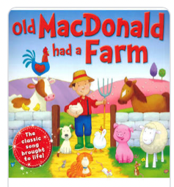  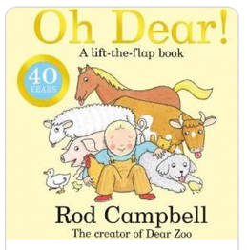  Oh Dear |  |  | 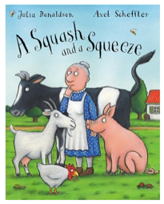  A squash and a squeeze |  | 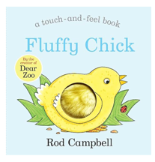  Fluffy Chick
Little Owls  Key Texts | 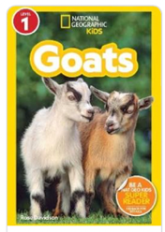  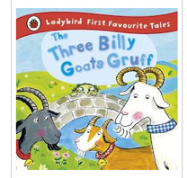  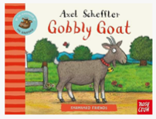  The Three Billy Goats Gruff / Goats / Gobbly Goat |  | 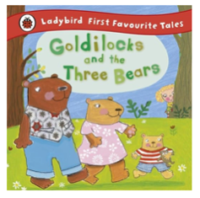  Goldilocks and the three bears | 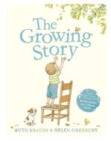  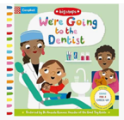  The Growing Story /  We’re going to the dentist | 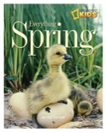  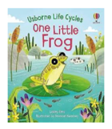  One Little Frog  Everything Spring | 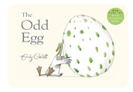  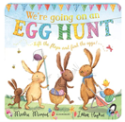  The Odd Egg  We’re going on an Egg Hunt

